

Google Cloud Platform

Process Document for Plus jobs in GCP

Table of Contents
Multi-Channel Attribution for Justice 1
Integration Requirements Document for File Transfer from Allant to Ovative 1
Revision Chart 3
Approvals 3
1. Introduction 4
1.1. Purpose 4
1.2 Scope 4
1.3 Dependencies 4
1.4 Assumptions 4
1.5 Brands 5
2 Bird’s Eye View of Data Processing in GCP 5
2.2 File Processing Details 6

3 Appendix A 9
3.1 Glossary 9

Revision Chart
This chart contains a history of the document’s revision
Version | Primary Author | Description of Change | Date Completed
1.0 | Sumant Karmakar | Initial Draft | 8th July, 2020

Approvals

Business Approval
A summary of the required approvals received for this document are captured below.
Name | Role | Approval Date

Reviewers/Contributors
In addition to the approvers, all individuals listed below should be included on any circulation of this document for review and feedback.
Name | Role | Reviewed Date

Introduction

Purpose

The purpose of this document is to define requirements and process associated with the integrations of below daily & historical feeds for PLUS in Google Cloud Platform(GCP).
- Plus Replenishment

Scope

1.2.1 In Scope

- Data transfer from CRM(Teradata), EDW(Teradata), FMW(Item & Store), Inventory
- Integrations requirements
- Historical Data Transfer
- Validation
- Logging
- Folder Structure

1.2.2 Out of Scope
- Not Sure as of now (7/08/2020)

Dependencies

Inter Project Dependencies
- File availability from FMW

External Project Dependencies
- NA

Assumptions
- GCP Integration Server Up and Running with Avaiable space to hold the data till it gets copied into the Bucket

Brands
Following brands are in scope for this flow –
Brand | In Scope
PLUS | Y

Bird’s Eye View of Data Processing in GCP
Data is being processed using three layers in BigQuery:
- Landing (Daily/Weekly Incremental Data)
- Staging (Historical Data + Daily/Weekly Incremental Data)
- Mart (Daily Transformed Data from Staging)
The GCP Integration Server gets data from CRM System, EDW System and FMW Team Daily directly or Via Hygiene Server. All of this data is generated at the source system end and SFTP’ed to the GCP Integartion Server. All of this data is then copied to the GCP Bucket using few Control-M jobs scheduled at specif time. These Control-M jobs trigger *.sh scripts, which starts the process of loading data to the Landing tables.
The *.sh Script contains run_bq_job –e script_name.bq command, which triggeres the bq scripts. When bq Scripts are triggered, the data is loaded into Landing tables. From here, it is processed with minimal changes and loaded into Staging tables.
Separate set of Mart jobs are used to load the Mart Tables, irrespective of failures in the Staging Process. If any of the table load job’s have failed during the Staging process, a mail is send to the aBS-IT-Data-Solutions team.

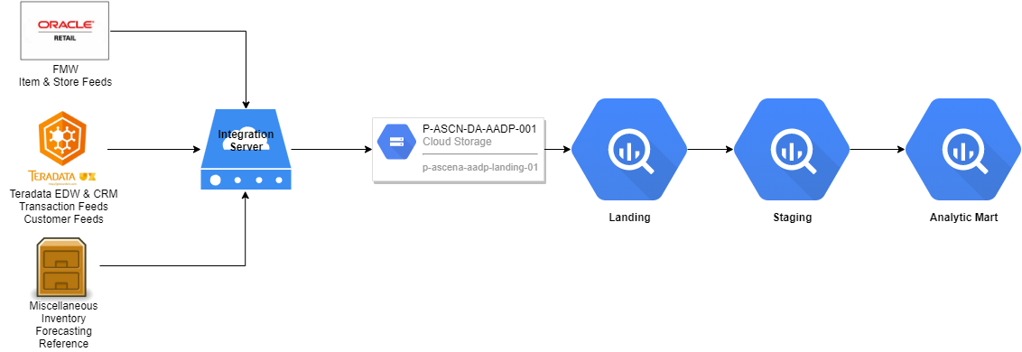

Job List & Defination

Control-M Job List
Sr. No | Source | Control-M Job Name | Start Time | Frequency | Defination | Target Destination
1. | FMW | CAT_GCP_ITEM_CDL_OUT_SFTP | 10 PM EST | Daily | FTP CA Item feed from FMW to GCP Integration Server | GCP Integraton Server
2. | FMW | LBR_GCP_ITEM_CDL_OUT_SFTP | 10 PM EST | Daily | FTP LB Item feed from FMW to GCP Integration Server | GCP Integraton Server
3. | FMW | CAT_GCP_STORE_CDL_OUT_SFTP | 10 PM EST | Daily | FTP CA Store feed from FMW to GCP Integration Server | GCP Integraton Server
4. | FMW | LBR_GCP_STORE_CDL_OUT_SFTP | 10 PM EST | Daily | FTP LB Store feed from FMW to GCP Integration Server | GCP Integraton Server
5. | FMW | ASC_CEM_TRANSACTION_TYPE_CDL_OUT_SFTP | 1:30 AM EST | Daily | Loads references data to GCP Integration Server | GCP Integration Server
6. | FMW | CAT/LBR_DOM_*, CAT/LBR_EDW_*  Details given in Appendix Forecasting |  | Daily | Laods Forecasting data from FMW to GCP Integration Server | GCP Integraton Server
7. | Teradata CRM System | PLS_CRM_GCP_EXTRACT  PLS_CRM_GCP_SFTP | 5:30 AM EST | Daily | Extract CRM data from Terdata and put the extracts into GCP Integration Server | GCP Integration Server
8. | Teradata EDW System | LBR_EDW_TRANS_GCP_EXTRACT  CAT_EDW_TRANS_GCP_EXTRACT  PLS_EDW_TRANS_GCP_SFTP | 5:30 AM EST | Daily | Extract EDWP_XX_RPT data from Teradata and put the Extracts into GCP Integration Server | GCP Integration Server
9. | GCP Integration Server | PLS_CRM_GCPBUCKET_LOAD | 6 AM EST | Daily | Loads CRM Extracts into GCP Bucket and Triggers plus_crm.sh | Landing -> Staging
10. | GCP Integration Server | PLS_EDW_TRANS_GCPBUCKET_LOAD | 6 AM EST | Daily | Loads EDW Extracts into GCP Bucket and Triggers plus_edw.sh | Landing -> Staging
11. | GCP Integration Server | PLS_GCP_ITEM_GCPBUCKET_LOAD | 8 AM EST | Daily | Loads ITEM Extracts into GCP Bucket and Triggers plus_item.sh | Landing -> Staging
12. | GCP Integration Server | PLS_GCP_STORE_GCPBUCKET_LOAD | 8 AM EST | Daily | Loads STORE Extracts into GCP Bucket and Triggers plus_store.sh | Landing -> Staging
13. | GCP Bigquery Staging | PLS_GCP_DATA_MART_DAILY_LOAD | 12:30 PM EST | Daily | Loads Data from all Staging tables into Mart based on Transformation Logic defined in bq Scripts | Analytic Mart
14. | GCP Integration Server | PLS_GCP_REFERENCE_GCPBUCKET_LOAD | 2 AM EST | Daily | Loads references data from Integration Server to GCP Bucket | GCP Bucket
15. | GCP Integration Server | PLS_GCP_FORECASTING_GCPBUCKET_LOAD | Cyclic Job from 7 AM | Daily | Loads Forecasting Files from GCP Integration Server to GCP Bucket | GCP Bucket
16. | GCP Integration Server | PLS_GCP_ACC_DF_WEEKLY_LOAD  (CAT_EDL_WEEK_PUSH_SFTP & LBR_EDL_WEEK_PUSH_SFTP are Predecessors which sends files from EFT to GCP) | 12:30 PM EST | Weekly | Loads the *_ACC_DF_* SKU_DC, SKU_STORE, SALES_SETTLEMENT into GCP Bucket from Integration Server. Trigers plus_inventory.sh | GCP Bucket -> Landing -> Staging

BQ Scripts List
Master Scripts | Child Scripts | Layer Loaded
plus_crm.sh | plus_tmci997_esp_outbound.bq  plus_vmci015_cust_ccard.bq  plus_vmci019_customer.bq  plus_vmci019_custonly.bq  plus_vmci021_cust_phone.bq  plus_vmci067_cust_block.bq  plus_vmci079_club_memb.bq  plus_vmci105_chain_cust.bq  plus_vmci172_chain_cust_email.bq  plus_vmci173_full_email_addr_status.bq  plus_vmci173_full_email_address.bq  plus_vmci180_cust_demog.bq  plus_vmci396_curr_opt_in_out_full.bq  plus_vmci972_chain_cust_fullemail.bq  plus_vmci995_esp_last_click_open.bq | Landing -> Staging
plus_edw.sh | plus_sales_transaction_header.bq  plus_sales_transaction_detail.bq  plus_sales_transaction_discount.bq  plus_sales_transaction_fee.bq  plus_sales_transaction_notes.bq  plus_sales_transaction_payment.bq  plus_sales_transaction_tax.bq  plus_sales_transaction_tender.bq  plus_sales_customer.bq | Landing -> Staging
plus_item.sh | plus_item_sku.bq | Landing -> Staging
plus_store.sh | plus_store.bq | Landing -> Staging
plus_mart_daily_load.sh | dim_item.bq  dim_store.bq  dim_brand_customer.bq  fact_transaction.bq  fact_transaction_detail.bq  fact_transaction_discount.bq  fact_transaction_notes.bq  fact_transaction_tender.bq  fact_transaction_tax.bq  fact_transaction_merch_line.bq  fact_transaction_fee.bq  transaction_customer_xref.bq  plus_brand_customer.bq  plus_brand_customer_demographics.bq  plus_brand_customer_phone.bq  plus_brand_customer_email.bq  plus_brand_customer_email_outbound.bq  plus_brand_customer_perks_membership.bq  plus_brand_customer_opt_in_out.bq  plus_brand_customer_account.bq  plus_brand_customer_mailing.bq  plus_brand_customer_direct_marketing_cell.bq  plus_brand_customer_clcst_gp.bq | Staging -> Analytic Mart
plus_inventory.sh | plus_store_sku_inventory.bq -> "plus_store_sku_cogs.bq" | Landing -> Staging

Folder/Bucket Structure and Enviroment Files

Scripts Folder Structure
- Environment Files: /home/gcpinteg/bin, /home/gcpinteg/lib
- BQ Scripts: /home/gcpinteg/script
- Validation Scripts: /home/gcpinteg/val
- Landing Script Schema Defination: /home/gcpinteg/schema/edl_landing/
- Processed Log Files: /home/gcpinteg/log
- Adhoc/One Time Load Scripts: /home/gcpinteg/util

Integration Server Folder Structure
Data from FMW, CRM, EDW, Inventory, Forecasting, References and Hierarchy are SFTP’ed here
- CRM Data: /data/plus/crm
- EDW Data: /data/plus/edw
- ITEM Data: /data/plus/item
- STORE Data: /data/plus/store
- Forecasting Data: /data/plus/forecasting
- Inventory Data: /data/plus/inventory
- Reference Data: /data/plus/reference
- Hierarchy Data: /data/plus/hier
- All the above given folders will have a /arc folder inside each folder and it has Day.tar.gz files.
For E.g.: if the files are processed on Monday then the file inside /arc will be Mon.tar.gz

Bucket and Folder Structure in GCP
- Master Bucket for all incoming Data: p-ascena-aadp-landing-01
- CRM Data: gs://p-ascena-aadp-landing-01/plus/crm/
- EDW Data: gs://p-ascena-aadp-landing-01/plus/edw/
- ITEM Data: gs://p-ascena-aadp-landing-01/plus/item/
- STORE Data: gs://p-ascena-aadp-landing-01/plus/store/
- FORECASTING Data: gs://p-ascena-aadp-landing-01/plus/forecasting/
- REFERENCES Data: gs://p-ascena-aadp-landing-01/plus/reference/
- INVENTORY Data: gs://p-ascena-aadp-landing-01/plus/inventory/
- PRODUCT HEIRARCHY Data: gs://p-ascena-aadp-landing-01/plus/hier/
- All of the above have gs://p-ascena-aadp-landing-01/plus/*/arc to archive files

Environment Files
- /home/gcpinteg/bin/gsload
This script has two functions, copy the data from GCP Integration Server to GCP Bucket based on the path given as the parameter, also based on the given path trigger the *.sh script. For e.g.: gsload -p p-ascn-da-aadp-001 -b p-ascena-aadp-landing-01 /data/plus/store/ will trigger plus_store.sh
- /home/gcpinteg/bin/run_bq_job
This command in internally used in the *.sh scripts to run a particular bq script. This also creates a log file in /home/gcpinteg/log and an entry in the edl_stage.bq_job_status with necessary details
- /home/gcpinteg/lib/common.sh
This files has common functions which are called in run_bq_job as well as some inside the bq scripts itself
- /home/gcpinteg/lin/set_env.sh
This script just sets the environment variables for PROD, DEV(NON_PROD) and TEST( NOT YET PRESENT) based on the run environment. Valirable like project name, bucket, script path, etc.

Data Flow from GCP Integ. Server to analytic_mart, Standards, Validation & Logging
In the above given Control-M Jobs list, Job No: 9 to 12 are the jobs which trigger a no of operations. It basically triggers gsload command:
gsload -p PROJECT_ID -b BUCKET_NAME /data/File_path/
For E.g: gsload -p p-ascn-da-aadp-001 -b p-ascena-aadp-landing-01 /data/plus/store/
This picks up all the files from that particular path and copies it on the bucket and instantly archives it in integration server /data/file_path/arc folder after two levels of Compression with Current days three letter name:
For E.g.: /data/plus/store/arc/Mon.tar.gz
Also, plus/store is converted into plus_store.sh
This includes, run_bq_job –e plus_store.bq. This will start running the bq job, will load Landing and Staging tables.
Based on when CRM, EDW, ITEM & STORE Staging loads are complete then, Mart Load Starts which is above given Control-M Job No.13
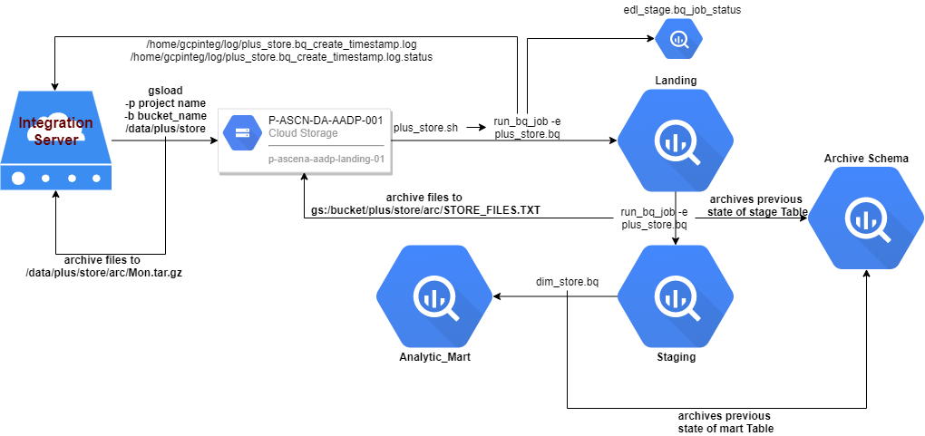

BQ Scripts Standards
- Each Scripts should include: set_env.sh, common.sh
- Bq load and temp table bq query load should include --replace=true, this will ensure that failure doesnot happen due to already present temp table from previous run.
- Schema_path, default_bucket
- PROJECT ID Should not be mentioned in the Scripts. That is by default mentioned in set_env.sh
- rc_check should be included after each command
- Each table should be pushed to edl_archive as part of incremental load
- archive_bucket_files should be included at the end of each Staging Scripts only to archive files in the GCP Bucket

Validation & Logging
All the Job Definition are present in edl_stage.bq_job_defn, details like brand, bq_name, job_type, load_type, etc.
When run_bq_job runs, it basically creates a log file in ~/log/table_name_*.bq_create_timestamp.log also, it inserts a Entry in the bq_job_status stating Successful/Waring/Failed.
After the bq script has completed running successfully, it triggeres table-val.bq script
For E.g: plus_store-val.bq
if the Validation script has failed then entry in the bq_job_status table will be inserted as ValidationError.

Appendix

Glossary
Term | Definition
EFT | Enterprise File Transfer
FTP | File Transfer Protocol
SFTP | Secure File Transfer Protocol
Source | Where data originates.
Target | Where data lands.
NON_PROD | Development/Testing Environment
PROD | Production
EST | Eastern Standard Time (USA)

